**Mini Project Report on**



**Multi -Modality Medical Image Fusion**



**Submitted in partial fulfilment of the requirement for the award of the degree of**

**BACHELOR OF TECHNOLOGY**

**IN**

**COMPUTER SCIENCE & ENGINEERING**

**Submitted by:**

**Student Name**  **University Roll No.**

**Naman Singhal 2018953**

***Under the Mentorship of***

**Dr. Manoj Diwaker**

**Associate Professor**



**Department of Computer Science and Engineering**

**Graphic Era (Deemed to be University)**

**Dehradun, Uttarakhand**

**July-2023**



**CANDIDATE’S DECLARATION**

I hereby certify that the work which is being presented in the project report entitled **“Multi -Modality Medical Image Fusion”** in partial fulfillment of the requirements for the award of the Degree of Bachelor of Technology in Computer Science and Engineeringof the Graphic Era (Deemed to be University), Dehradun shall be carried out by the under the mentorship of **Dr.Manoj Diwaker Associate Professor**, Department of Computer Science and Engineering, Graphic Era (Deemed to be University), Dehradun.

Naman Singhal 2018953

**Table of Contents**

|  |  |  |
| --- | --- | --- |
| **Chapter No.** | **Description** | **Page No.** |
| Chapter 1 | Introduction | **1-2** |
| Chapter 2 | Literature Survey | **3-6** |
| Chapter 3 | Methodology | **7-10** |
| Chapter 4 | Result and Discussion | **11-12** |
| Chapter 5 | Conclusion and Future Work | **13-14** |
|  | References | **15** |

**Chapter 1**

**Introduction**

* 1. **Introduction**

Multimodality is the use of multiple modes of communication to convey meaning. This can include the use of text, images, audio, video, and even gesture or movement. Multimodality is becoming increasingly important in the digital age, as people are increasingly consuming information through a variety of channels. There are many benefits to using multimodality. First, it can help to make information more accessible to a wider audience. For example, a video with captions can be understood by people who are deaf or hard of hearing, and a website with images can be understood by people who are blind or have low vision. Second, multimodality can help to make information more engaging. When people are able to use multiple senses to learn, they are more likely to retain the information. For example, a presentation that includes both text and images is more likely to be remembered than a presentation that is just text. Third, multimodality can help to create a more immersive experience. When people are able to interact with information in multiple ways, they are more likely to feel like they are part of the experience. For example, a virtual reality game that allows people to explore a real-world environment is more immersive than a traditional video game.

Multimodality medical fusion, also known as multimodal medical image fusion or multimodal medical imaging fusion, refers to the integration or combination of information from multiple imaging modalities to provide a more comprehensive and accurate representation of a patient's anatomy or pathology. In medical imaging, different modalities, such as computed tomography (CT), magnetic resonance imaging (MRI), positron emission tomography (PET), single-photon emission computed tomography (SPECT), ultrasound, and others, can offer unique and complementary information about the human body.

By fusing or merging the data obtained from these different imaging modalities, clinicians and researchers can benefit from a more complete and enhanced visualization of the underlying structures, tissues, or pathologies. The fusion process involves aligning and combining the information from multiple modalities into a single integrated representation, which can aid in diagnosis, treatment planning, monitoring of disease progression, and other medical applications.

Multimodality medical fusion techniques can be categorized into two main types: spatial fusion and feature-level fusion.

1. Spatial Fusion: Spatial fusion involves the registration and alignment of images acquired from different modalities into a common coordinate system. This enables the spatially aligned images to be displayed together, facilitating a side-by-side or overlaid visualization. Spatial fusion techniques often involve mathematical transformations and algorithms to align the images based on anatomical landmarks or other image features.

2. Feature-Level Fusion: Feature-level fusion focuses on combining specific image features or characteristics extracted from each modality to generate a fused representation. This technique involves extracting relevant information from each modality, such as edges, textures, or intensity values, and combining them to create a composite image or feature set that captures the complementary information.

The fused images or information resulting from multimodality medical fusion can provide clinicians with a more comprehensive understanding of a patient's condition, leading to improved diagnosis, treatment planning, and patient management. It can help overcome limitations or ambiguities associated with individual imaging modalities and provide a more accurate and reliable assessment of complex medical cases.

**Chapter 2**

**Literature Survey**

Medical image fusion techniques aim to combine multiple images from different modalities or sources to enhance the visualization of relevant information. Here are several commonly used medical image fusion techniques:

Intensity-based Fusion:

Averaging: The pixel intensities of corresponding pixels in the input images are averaged to generate the fused image.

Weighted averaging: The pixel intensities are weighted according to their respective importance or reliability.

Maximum selection: The maximum pixel intensity among the input images is chosen for each pixel position in the fused image.

Minimum selection: The minimum pixel intensity among the input images is chosen for each pixel position.

Transform-based Fusion:

Wavelet transform: Input images are decomposed into wavelet coefficients, and fusion is performed on the coefficients at different scales and orientations.

Discrete Cosine Transform (DCT): Images are transformed into the frequency domain using DCT, and fusion is performed on the DCT coefficients.

Principal Component Analysis (PCA): Images are represented using the principal components, and fusion is performed by combining the principal components.

Spatial Domain Fusion:

Pixel-based fusion: Individual pixel values from input images are combined using predefined rules or operators.

Region-based fusion: Regions of interest (ROIs) are identified in input images, and fusion is performed at the region level, preserving important details.

Multi-resolution Fusion:

Laplacian pyramid: Input images are decomposed into multiple resolution levels, and fusion is performed on corresponding pyramid levels.

Multi-resolution analysis: Images are decomposed using multi-resolution techniques such as the discrete wavelet transform or the scale-invariant feature transform (SIFT).

Sparse Representation-based Fusion:

Sparse representation: Input images are represented as sparse linear combinations of basis functions, and fusion is performed by combining the sparse coefficients.

Deep Learning-based Fusion:

Convolutional Neural Networks (CNN): Deep learning models can be trained to learn feature representations from input images and generate fused images.

Generative Adversarial Networks (GAN): GANs can be used to generate high-quality fused images by learning from a set of training images.

These techniques are commonly used in medical image fusion, and the choice of technique depends on the specific requirements, characteristics of the input images, and the desired output. Researchers continue to explore and develop new fusion techniques to improve the quality and accuracy of medical image analysis and diagnosis.

Traditional Image Fusion Techniques:

Early image fusion methods were based on simple mathematical operations such as averaging, weighted averaging, and max-min approaches. Although these techniques were straightforward, they suffered from limited performance in preserving fine details and effectively utilizing the complementary information from different modalities. Nevertheless, they laid the foundation for more advanced fusion algorithms.

Transform Domain Techniques:

Researchers then explored transform domain techniques, such as wavelet, curvelet, and shearlet transforms, which demonstrated significant improvements in preserving both spatial and spectral information. Wavelet-based methods, in particular, became widely adopted for their ability to handle multi-resolution representations and offer a good compromise between detail preservation and noise reduction.

Sparse Representation and Compressed Sensing:

Sparse representation and compressed sensing techniques emerged as powerful tools for multi-modality image fusion. These methods leverage the sparsity of image data in certain domains, such as wavelets or dictionaries, to efficiently combine information from different sources while reducing artifacts and noise.

Deep Learning-Based Approaches:

With the advent of deep learning, Convolutional Neural Networks (CNNs) and Generative Adversarial Networks (GANs) have revolutionized multi-modality image fusion. These methods learn complex mappings between input modalities, leading to superior results in terms of both image quality and feature representation. CNN-based approaches, in particular, have shown promising results in medical imaging applications, like fusing MRI and CT scans for improved disease diagnosis.

Quality Assessment Metrics:

As multi-modality image fusion is utilized in critical applications such as medical diagnosis, evaluating the quality of fused images is crucial. Researchers have developed various objective and subjective metrics to assess the performance of fusion algorithms, including mutual information, Structural Similarity Index (SSIM), and human visual perception studies.

Challenges:

Despite significant progress, several challenges persist in multi-modality image fusion. Alignment and registration of different modalities remain a critical issue, as slight misalignments can lead to inaccurate fusion results. Another challenge is handling varying modalities with different resolutions and noise levels, requiring sophisticated techniques for data normalization and noise reduction.

Applications:

Multi-modality image fusion finds application in various fields. In medical imaging, it aids in accurate diagnosis and treatment planning by combining information from MRI, CT, PET, and ultrasound scans. In remote sensing, it enhances satellite and aerial imagery for land use classification, environmental monitoring, and disaster management. Additionally, in robotics and autonomous systems, fusion of visual and depth data enables better perception and decision-making capabilities.

**Chapter 3**

**Methodology**

Image restoration is a fundamental image processing technique aimed at improving the quality and clarity of a degraded or distorted image. The process involves the removal or mitigation of various types of degradations that may occur during image acquisition, transmission, or storage. Image restoration plays a crucial role in various applications, such as medical imaging, surveillance, remote sensing, and photography, where high-quality images are essential for accurate analysis and interpretation.

Degradations in Images:

Images can undergo several types of degradations, leading to a loss of image quality and important information. Some common degradation types include:

Blurring: Blurring occurs when the image loses sharpness and fine details due to motion during image capture or lens imperfections. It can be caused by camera shake, defocus, or atmospheric turbulence.

Noise: Noise is random variations in pixel values caused by electronic or environmental factors during image acquisition. Common noise types include Gaussian noise, salt-and-pepper noise, and speckle noise.

Compression Artifacts: Lossy image compression techniques can introduce compression artifacts, leading to a loss of image details and blocky or ringing patterns.

Illumination Variations: Uneven lighting or illumination changes can result in uneven brightness across the image, making it difficult to perceive important details.

Image Restoration Techniques:

Image restoration techniques aim to reverse or minimize the effects of degradations to recover the original or an enhanced version of the image. Different approaches are used depending on the type of degradation and the available information about the degradation process.

Spatial Domain Techniques:

Spatial domain techniques operate directly on the pixel values of the degraded image. They include:

a. Wiener Filter: The Wiener filter is an optimal linear filter that can restore a degraded image by minimizing the mean square error between the original and observed image. It requires knowledge of the degradation process and the noise characteristics.

b. Inverse Filtering: Inverse filtering attempts to directly reverse the degradation process by dividing the Fourier transform of the degraded image by the known degradation function's Fourier transform. However, it is sensitive to noise and may lead to amplification of noise.

Wavelet-Based Techniques:

Wavelet-based restoration methods utilize wavelet transforms to decompose images into different frequency bands. These methods are effective in handling both blurring and noise.

Deep Learning-Based Techniques:

With the advent of deep learning, Convolutional Neural Networks (CNNs) have shown remarkable performance in image restoration tasks. These networks can learn complex mappings from degraded images to clean images, allowing for restoration without explicit knowledge of the degradation process.

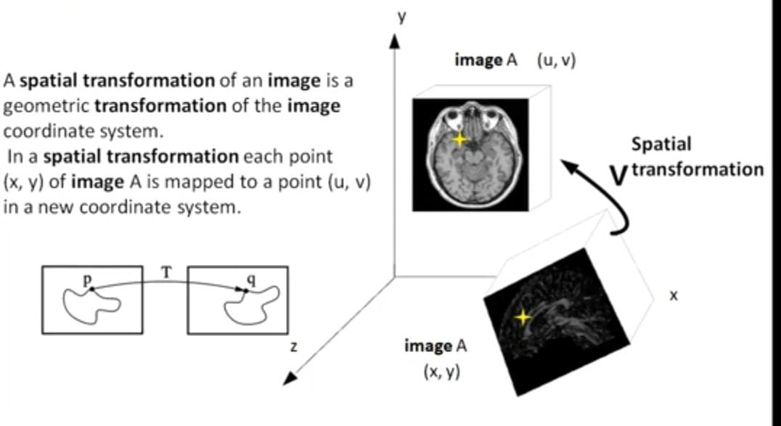

**Fig. 1.0**

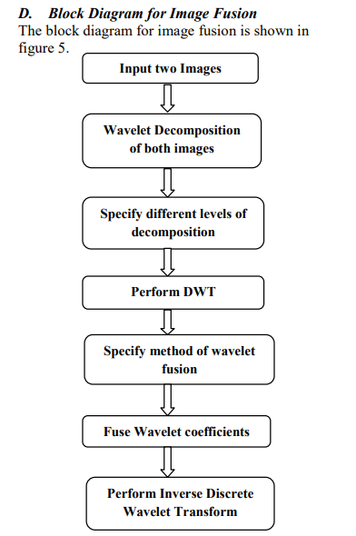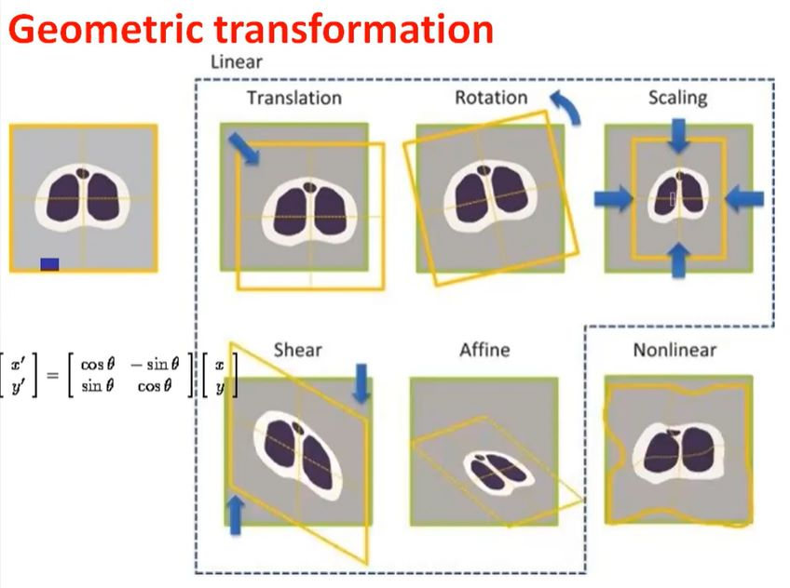

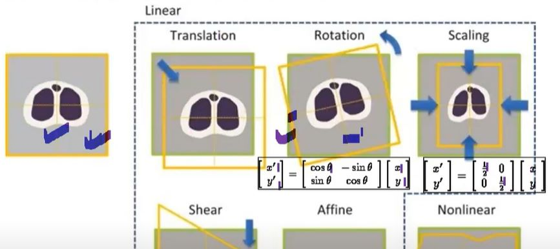 **Fig.3.1**

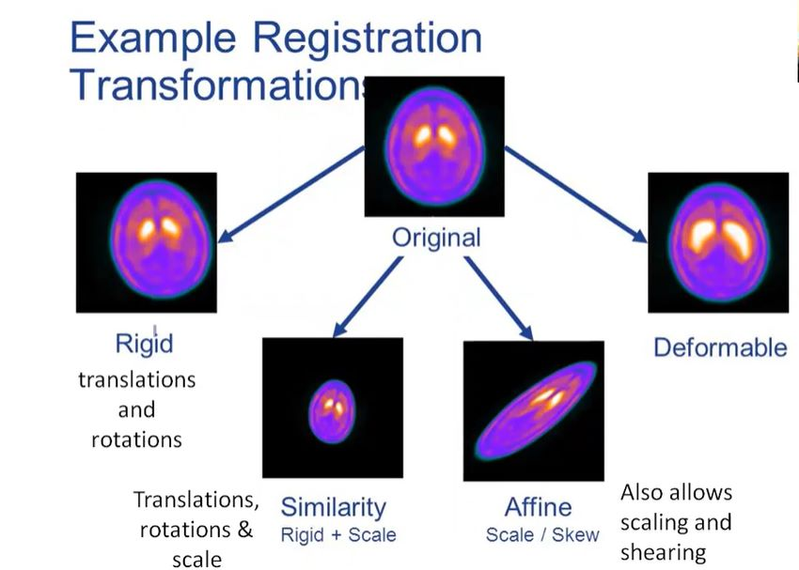 **Fig.2.0**

**Fig.3.2**

**Fig.4.0**

Image fusion using Discrete Wavelet Transform (DWT) is a popular technique that combines information from multiple images or image sources to create a single fused image. The process involves decomposing the input images into wavelet coefficients using DWT, fusing the coefficients, and then reconstructing the fused image from the modified coefficients. Image fusion using DWT offers several advantages, including the ability to handle multi-resolution representations and preserve both spatial and spectral information from the input images. Here's an overview of the image fusion process using DWT:

Decomposition:

The first step in image fusion using DWT is to decompose the input images into wavelet coefficients. The DWT decomposes the image into approximation (low-frequency) and detail (high-frequency) coefficients at different scales. The decomposition is performed iteratively, generating multiple levels of wavelet coefficients.

Fusion Rule:

Once the wavelet coefficients are obtained for all input images, a fusion rule is applied to combine the coefficients and create the fused coefficients. The fusion rule can be as simple as selecting the maximum or average value at each wavelet coefficient position, or it can be more complex, considering factors such as image content, spatial frequency, or statistical measures.

Reconstruction:

After obtaining the fused coefficients, the next step is to reconstruct the fused image from these coefficients. The inverse DWT (IDWT) is used to combine the fused coefficients to reconstruct the fused image. The IDWT involves upsampling the fused coefficients, applying the inverse low-pass and high-pass filters, and then adding the results to obtain the final fused image.

Post-processing:

Depending on the specific application and the fusion rule used, post-processing may be applied to further enhance the fused image. This can include noise reduction, contrast adjustment, or any other necessary image processing steps to achieve the desired result.

**Chapter 4**

**Result and Discussion**

cA = fusion1(cA1, cA2)

Here, CA represents the approximation coefficients of the fused image, obtained by applying "fusion1" to the approximation coefficients cA1 and cA2 of the two input images.

Explanation: The approximation coefficients (cA) represent the low-frequency information of the images after applying the Discrete Wavelet Transform (DWT). These coefficients contain the coarse approximation of the original image. The fusion1 function takes cA1 and cA2 as input and combines them to produce the fused approximation coefficients (CA). The specific fusion method used in fusion1 may involve mathematical operations such as averaging, weighted averaging, or more sophisticated techniques based on the characteristics of the input images.

cH = fusion2(cH1, cH2)

In this case, CH represents the horizontal detail coefficients of the fused image, which are obtained by applying "fusion2" to the horizontal detail coefficients cH1 and cH2 of the two input images.

Explanation: The horizontal detail coefficients (cH) capture the high-frequency horizontal components of the images after DWT. They represent the horizontal edges and fine details in the images. The fusion2 function takes cH1 and cH2 as input and combines them to produce the fused horizontal detail coefficients (CH).

cV = fusion2(cV1, cV2)

Similarly, CV represents the vertical detail coefficients of the fused image, obtained by applying "fusion2" to the vertical detail coefficients cV1 and cV2 of the two input images.

Explanation: The vertical detail coefficients (cV) capture the high-frequency vertical components of the images after DWT. They represent the vertical edges and fine details in the images. The fusion2 function takes cV1 and cV2 as input and combines them to produce the fused vertical detail coefficients (CV).

cD = fusion2(cD1, cD2)

Here, cD represents the diagonal detail coefficients of the fused image, which are obtained by applying "fusion2" to the diagonal detail coefficients cD1 and cD2 of the two input images.

Explanation: The diagonal detail coefficients (cD) capture the high-frequency diagonal components of the images after DWT. They represent diagonal edges and fine details in the images. The fusion2 function takes cD1 and cD2 as input and combines them to produce the fused diagonal detail coefficients (cD).

**Chapter 5**

**Conclusion and Future Work**

In a variety of applications, such as medical imaging, remote sensing, computer vision, and more, image fusion has several benefits. The following are some of the main benefits of image fusion:

1. Enhanced Information: Image fusion combines information from several sources or modalities, enabling a more thorough depiction of the underlying scene or object. The fused image can give a better and more comprehensive knowledge of the observed phenomenon by combining data from many sensors or imaging modalities. Tasks involving decision-making, analysis, and interpretation can benefit from this improved knowledge.

2. Better Image Quality: By minimising the drawbacks or shortcomings of individual input photos, image fusion techniques can enhance the overall quality of the final image. It can improve the fused image's resolution, contrast, dynamic range, and overall aesthetic appeal, making it simpler for automated algorithms or human viewers to extract valuable information.

3. Enhanced Robustness and Reliability: Image fusion can increase the analysis's robustness and reliability by combining data from many sources. It aids in making up for the restrictions or uncertainties related to specific sources or modalities. By minimising noise, artefacts, and ambiguities, the fused image can offer a more trustworthy representation, facilitating more precise and consistent interpretations.

4. Supporting Data: Various imaging modalities or sensors record various facets of a scene or an item. Combining complementary information, such as spatial details, spectral characteristics, temporal dynamics, or other pertinent properties, is possible via image fusion. By combining complementary data, it is possible to better identify, categorise, segment, or track items or areas of interest, which improves our comprehension of the scene as a whole. 5. Better Object Detection and Pattern Recognition: Image fusion can improve the Object Detection and Pattern Recognition of Images. Image fusion can improve discriminative power and lower false positives or false negatives by combining the advantages of many modalities or sensors. Applications like object detection, target recognition, medical diagnostics, and surveillance can all benefit greatly from this.

6. Lessened Data Redundancy: Image fusion can assist in minimising the redundancy that exists between different photographs of the same scene or object. Fusion techniques enable the condensing of data into a single image or representation as opposed to storing or transmitting numerous independent images. This results in more effective data transmission, processing, and storage, which can be beneficial in contexts with limited resources. These benefits show how image fusion has the potential to enhance the accuracy, dependability, and interpretability of imaging data, facilitating more efficient analysis and comprehension of complex processes.

The experimental results show that the wavelet transform is a powerful method for image fusion. This method gives encouraging results in terms of PSNR and MSE. Also from the results it was observed that the maximum minimum fusion rule along with Haar wavelet gives better results and the values of PSNR increase and MSE decrease as the decomposition level increases.

**References**

[1] H. H. Wang, “A new multiwavelet-based approach to image fusion”,Journal of Mathematical Imaging and Vision, vol.21, pp.177-192,Sep 2004.

[2] V. Petrovic and C. Xydeas, “Evaluation of image fusion performance with visible differences”, Lecture Notes in Computer Science, vol.3023, 2004.

[3] G. Pajares, J. M. l de la Cruz, “A waveletbased image fusion tutorial”,Pattern Recognition, vol.37, pp.1855– 1872, 2004.

[4] C.Y.Wen, J.K.Chen, “Multi-resolution image fusion technique and its application to forensic science”, Forensic Science International, vol 140, pp-217-232, 2004.